Advanced coding tools project : Wave Visualisator

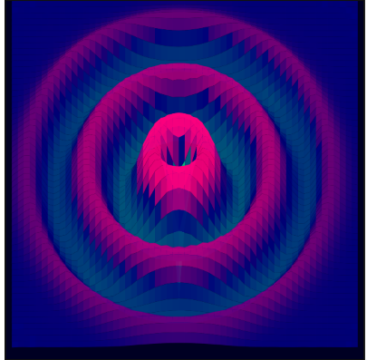

Introduction:
The aim of the project was to design a graphic representation of different kind of waves using the tools given to us in class. With the graphic representation we also implemented some audio and firebase feature allowing the users to see the soundwaves produced by their environment and their friends’.

Graphic render:
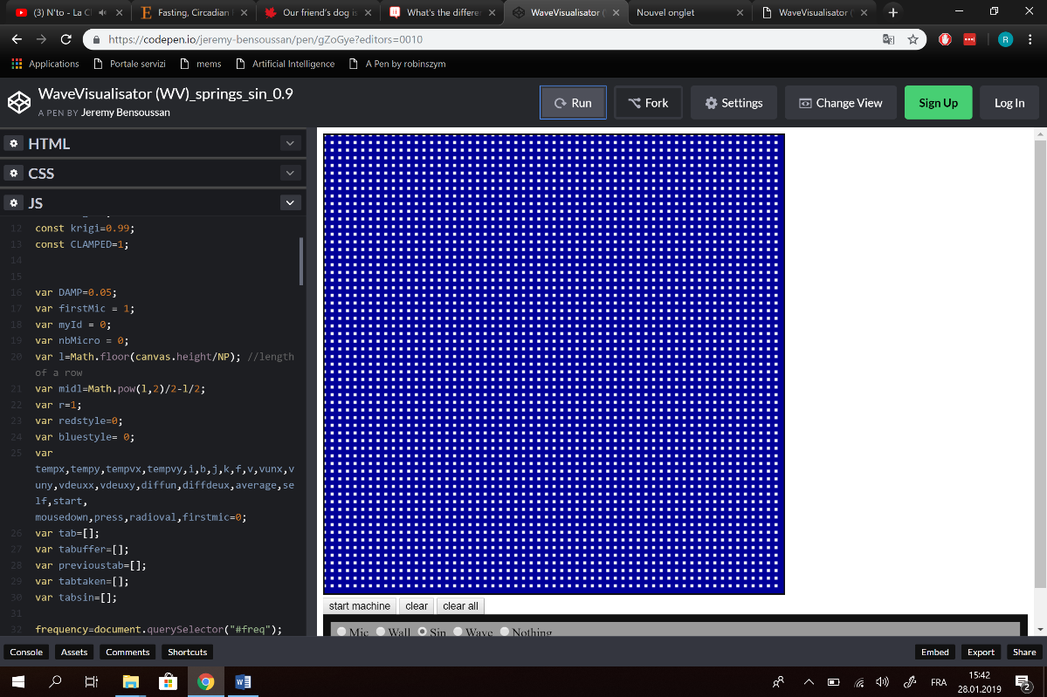
The graphic render tries to approximate a surface on a canvas where waves can be observed (water, piece of cloth). To do so we created a matrix of dots (figure 1) in Javascript where each dot precisely represents the position of the cloth in a 3d system.
Figure 1; matrix of dots.
The graphic rendering is done by using the canvas API, the position x (horizontal) is kept for each dot but the position z is added to the initial position y (vertical) to create a 3d effect (figure 2). Dots are linked together and coloured to create the tile effect, each tile is coloured by taking the average position of the 4 dots and putting it in a linear function of red for positive value (uphill) and green for negative ones (downhill). The colouring is made a little bit transparent, so we can see through the hills the perturbations.

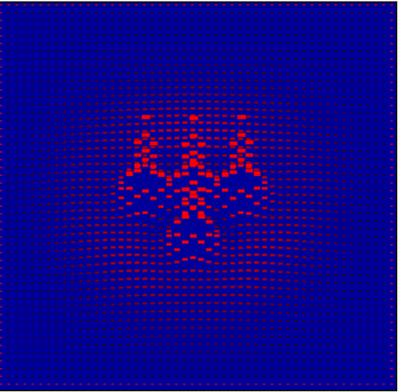
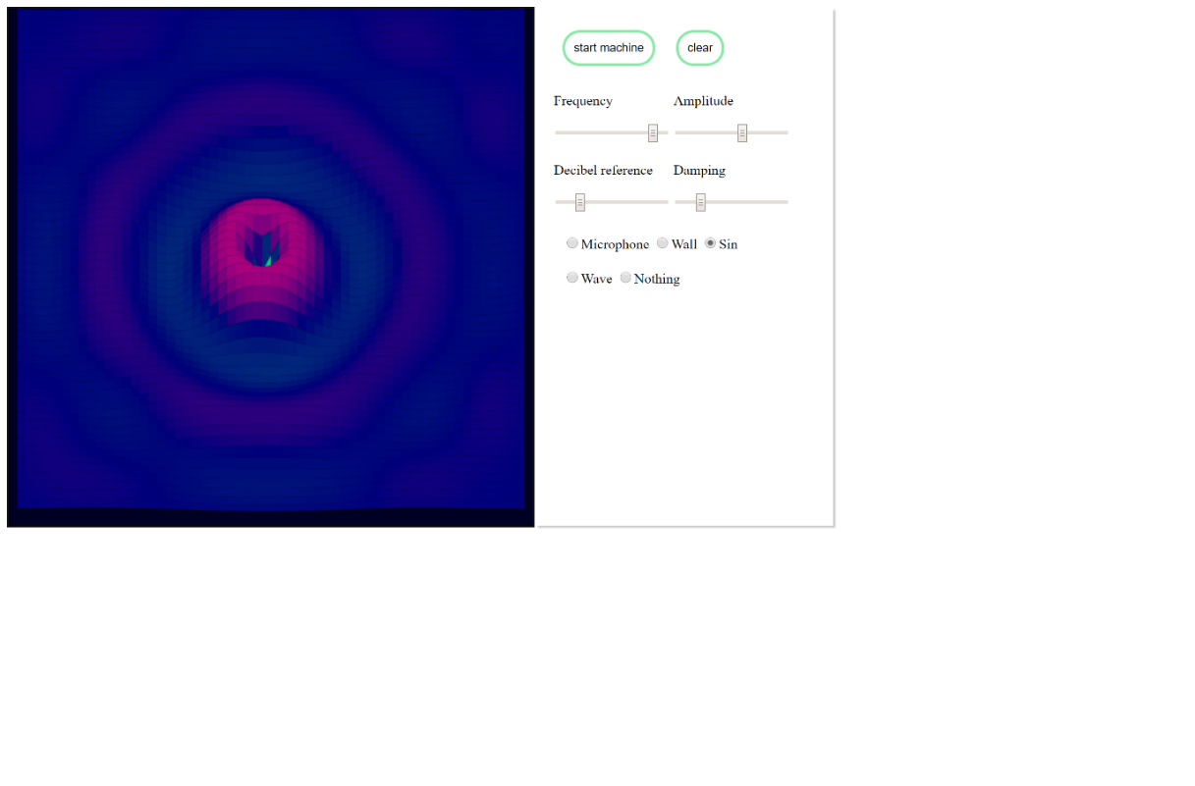
Figure 2 : dots are set in motion.
Figure 3 ; dots are linked and coloured.

Physical engine:
Each dot is attached to the others with the damped spring equation of motion
X’’+ bX’+kX=0
Where b is the damping coefficient, K the rigidity and X’’, X’ and X respectively the acceleration, speed and position.
At each frame the matrix is updated with the function nextStep who compute for each dot the new position (height, noted z in the code).
Border of the matrix: special condition are applied to the 4 sides of the matrix in order to have wave bounce. Satisfactory wave bounce can be observed when the sides are forced to 0 or when they are the average between the actual position and the previous one.

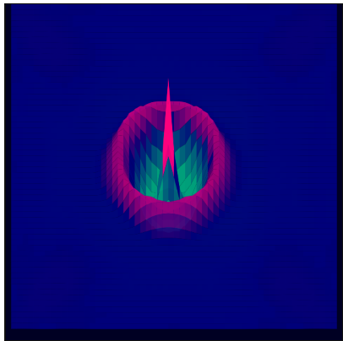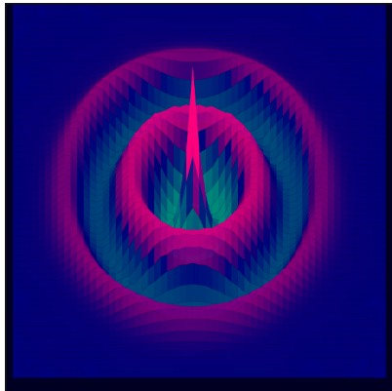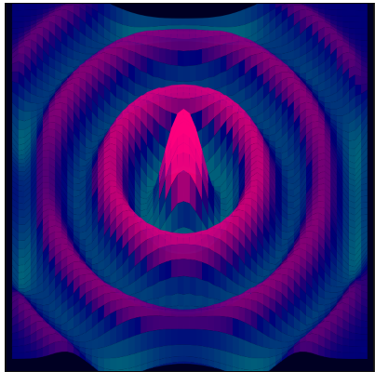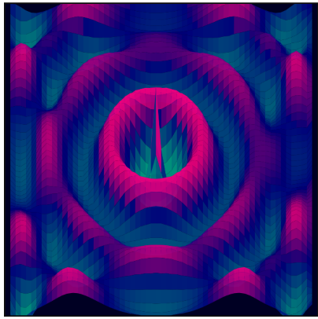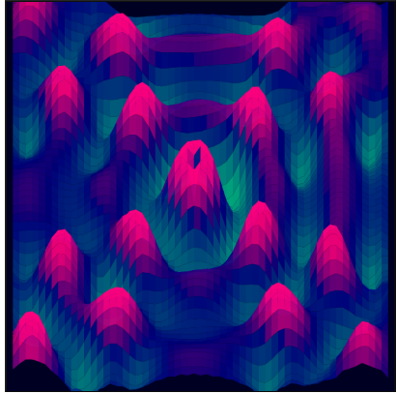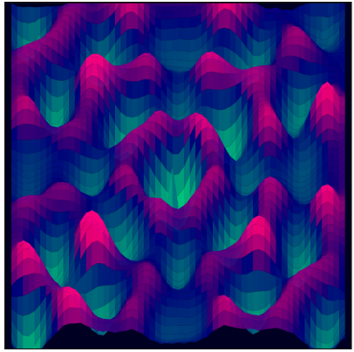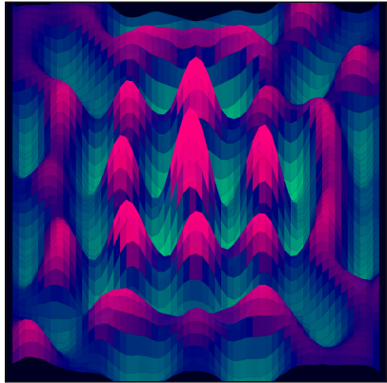
This set of screen shots shows the travel of the wave with 5 frames difference each. We can see the wave bounce of the side to create an interference pattern.

Sound Recording:

The sound system is made to record the microphone of the user and return the number of decibels of the recorded sound.
This is done through the function getSound which creates a system able to record the sound and analyse it.

We create a mediaStreamSource that will design the object that will record the audio flux.
To do so, the system will ask to the user the authorization for the use of the microphone.
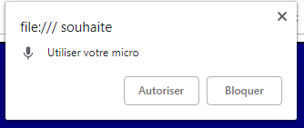

We connect this mediaStramSource that is the microphone to an analyser. This analyser is an audio node that will transmit the flux from an input to an output by capturing essential data on the frequency or temporal domain. Therefore, it will give us in real time the information data that we need.
We connect this analyser to a ScriptProcessorNode that is a buffer allowing the treatment of the pieces of information given after the analysis.
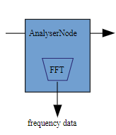
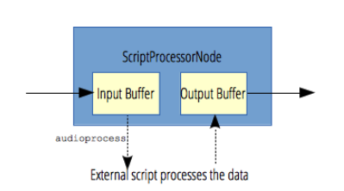
MediaStreamSource
Output

Therefore, after creating the system, we can compute the decibel recorded and return it. This data will be registered in the firebase and then displayed.

Firebase:

The firebase is created to get all the decibels from all the microphones of the different online users. Each time a user adds a microphone by clicking on the blue screen, we add a microphone locally in an array and then online.
Each user has locally a list of all its microphones and their respective position.

The firebase is composed of multiple users (a first array) that can have multiple microphone (another array). All the microphones of the user have the same sound because they record the same environment.

A microphone is an object characterized by its sound volume (average), its position in the tab (i) and its position in the scene (x,y)

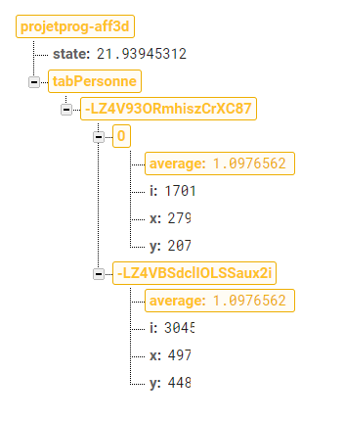
Microphone 2
User 1
Microphone 1 with :
- Average = volume recorded
- i = position in the tab
- x,y position in the scene
Array of users

The setAverage function is in the function getting the sound. Therefore, we constantly update the decibel of the person and update it in the firebase.
Each time a change is detected in the firebase, we get back the data through the function newData. This function reads in the firebase the data of all the microphones and calls the display function. Therefore, all the microphone will be displayed. Our own microphones and the other users who connected on the firebase.

The remove function is called when we press the “Clear” button. This function will only clear the local array of microphone and delete the user in the firebase.
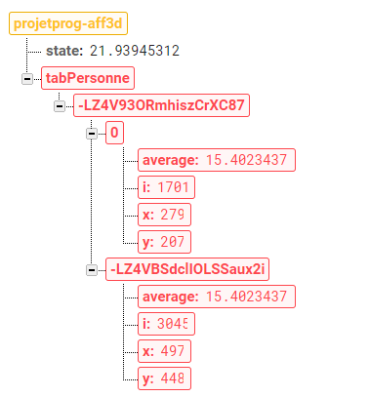

Since a change will occur in the firebase, the newData function will be called and the display will stop displaying the microphone that we cleared.

User’s guide:

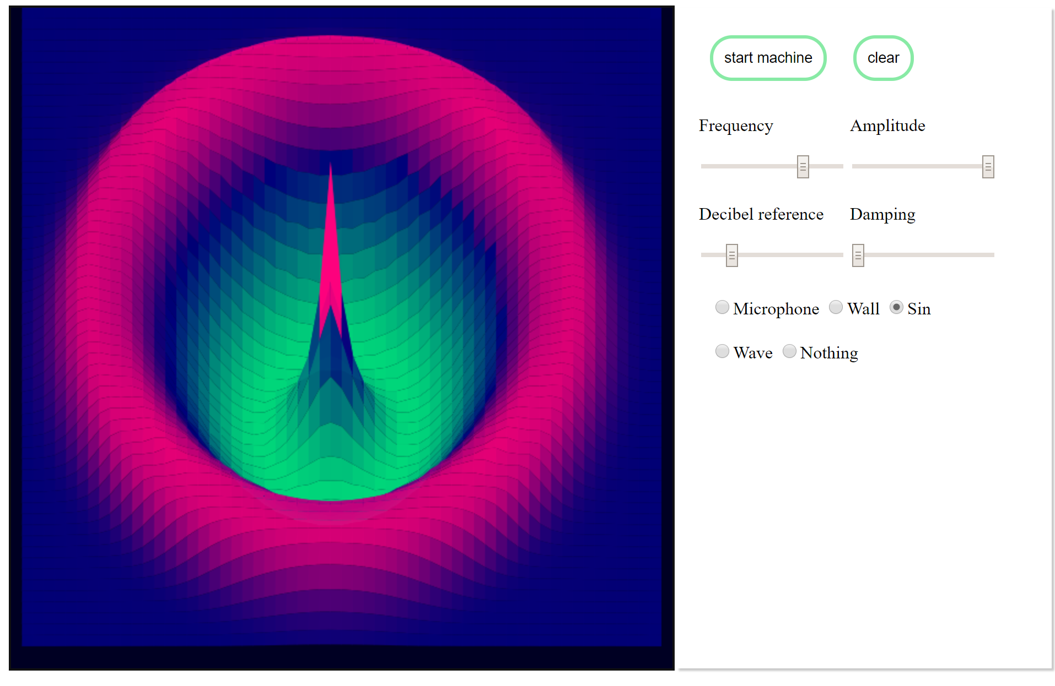

The programme lets you add microphones and sinus waves when you click on the interface with their respective radio button checked.
You can start the animation with start and clear it with the clear button. The amplitude and frequency of the sinus wave is mastered by the corresponding sliders.
The decibel reference allows you to change the 0 of the microphones (if you put it at 20 db and the surrounding sound is 20 the visualisator will appear flat). Recorded sound under the decibel reference will be displayed as a green valley, and red hill if above.
The damping sliders allows you to change the damping coefficient in order to make the wave vanish after a desired time. It is directly corelated to the damped spring equation shown in the physique explanation noted b.
When the wave radio button is clicked the simulation will make waves when clicked upon.
The wall radio button allows you to redefine the border of the simulation on click and hoover.

